STATE DEPARTMENT OF VOCATION AND TECHNICAL TRAINING
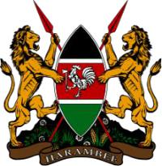
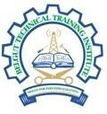

BELGUT TECHNICAL TRAINING INSTITUTE
- O BOX 205-20205, KERICHO-KENYA. Tel: +254759764059/+254728852244
website: www.belgutitechnical.ac.ke ,Email: belgutitechnical@gmail.com

MOTTO: SKILLS FOR NDUSTRIALIZATION

HAIRDRESSING REQUIREMENT

The course requirements for the above training are as follows

- 1 Apron -Navy-Blue (Can be obtained from the institute)

- 1 Combs – 3 In 1, Afro comb, Tail Comb

- Two Counter Books

- One Dummy Short African hair

- One Hair Food

- 1 set of hair Pins

- One Manicure Set

- One Nail Hardener

- 1 set of rollers

- Threads and Needle – (Black)

- 1 Top Coat and Base Coat

- Four medium white Towels

- One white round neck T-Shirt

